Instruction

# Description

* This objective of this file is to instruct you on how to solve the bi-level network design problem using GA in Matlab.
* This course does not require you to code GA yourself. However, you should be able to use it as a toolbox to solve the problem.
* This folder contains four folders each folder corresponding a small task explained in the next section.

# Reference

* About Genetic algorithm (GA): <https://en.wikipedia.org/wiki/Genetic_algorithm>
* Matlab help documents <https://se.mathworks.com/help/gads/ga.html>

# Self-study Examples and Exercises

## **Example 1 Code & decode GA**

Objective

* Know how to decode binary GA presentation to variables

Code

* Study the code “Example 1 decode GA”

Exercise 1:

Given [1,0,1,0,1,1,1,0,0,1]

1. If it represents a integer value, what it is ?
2. If it represents a continuous value between 4 and 8, what is it?

## **Example 2 familiar with basic MATLAB GA syntax**

Objective

* Use the basic syntax of GA

Code

* Folder “Basic GA”

Exercise 2

Solve the following function with constraints that x is an integer



You need to change the fitness function in the given code

## **Example 3 Simple bilevel model**

Objective

* Understand the basic bilevel structure and how it can be solved by GA

Code

* Folder “Simple Bilevel”
* Problem (the example has been introduced in the course)



where



Exercise 3

* How to add additional boundary constraints for  and 

## **Example 4 Simple bilevel network Design**

Objective

* Solve simple bilevel network design problem

Code

* Folder “network design”
* Problem description for this example
  + You are given a network containing 4 nodes and 12 links, the weights represent the travel times associated with the 12 links.
  + The objective of the model is to select 4 links to form a transit network, such that the sum of the travel times of A-C, A-B, and A-D is the minimum. In other words, we need to find the shortest travel time between these pairs of nodes.
  + The way I code is to create 4 variables. Each variable is an integer between 1 to 12, representing which link is selected.

Exercise 4

* In the given example, I only consider the demand. Now you need to work out how to consider the demand. The following demand values are known.
* Node A –> B: 50 passengers
* Node A –> C: 60 passengers
* Node A –> D: 25 passengers
* Instead of only building 4 links. You can build as many links as possible. However, the operation cost on every link is $50
* Assume passengers only use the shortest path, design a network that minimizes the total cost including passengers' travel time cost and operation cost.

## **Example 5 Simple Frequency Design**

Objective

* Solve transit frequency design problem

Input:

Network Example In the class

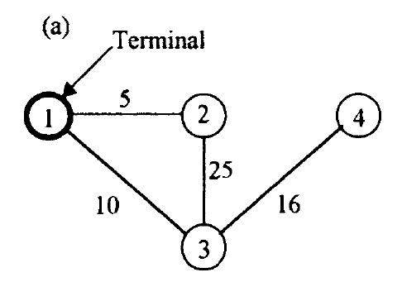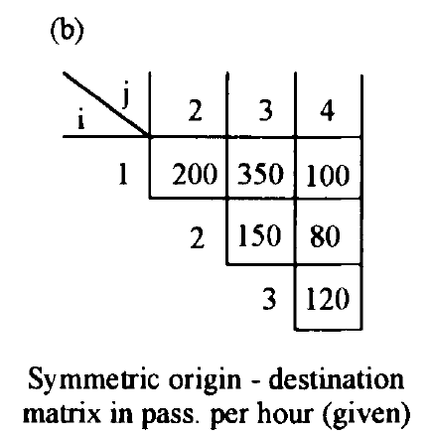

1 -> 2 : 5 min

1 -> 2 - > 3 : 30 min

1 -> 3 : 10 min

1 -> 3-> 4 : 26 min

Assumptions:

* Passengers travel through the shortest path
* The waiting time is half of the headway
* Operation Cost depends on frequency and is given by

1000 * Frequency

* The minimum frequency is 2, while the maximum frequency is 12

Exercise 5

Determine the frequency setting that minimizes the total travel cost.

Recommadations:

1. Define and code decstion variables
2. Define the lower level and upper level problem
3. Code the lower level problem
4. Solve the model

# %Remarks on the extensions

* You could consider a more complicated assignment model as the lower level problem by changing the lower-level code
* You can consider frequency as a variable in the network design problem.